**Category 6A Shielded Keystone Jack**

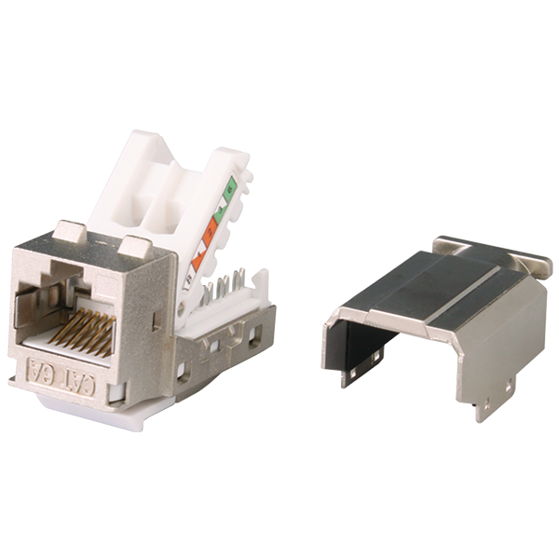

Category 6A shielded keystone jack supports the 10/100/1G BASE-T Ethernet, as well as advanced new 10G BASE-T Ethernet. The shielded jack with industrial leading transmission performance and provide an exceptional level of headroom, meets and exceeds ANSI/TIA-568.2-D and ISO/IEC 11801 2nd edition Category 6A standards. Zinc-alloy metal shell balances/eliminates the Alien crosstalk while the data is at high speed transmission. Narrow width design fits 1U 24-port empty panel for the most efficient use of rack space.

## **Features**

Zinc-alloy metal shell

Tool-free, no additional tool required for termination

Contacts are phosphor bronze plated with 50 micro inches of hard gold

Dual T568A &amp; T568B wiring

Polycarbonate 94V0 rated

Force EC Cat.8/Class I Channel certified

4PPoE compliant in accordance with IEEE802.bt Type 4

**Ordering Information**

|  |  |
| --- | --- |
| **Part No.** | **Description** |
| **1A68TPZA0** | RJ45, 8-Conductor Cat.6A , Tool-free, Shielded, 180 degree, H.D. version |
| **1A68IPZA0** | RJ45, 8-Conductor Cat.6A , 110 IDC, Shielded, 180 degree, H.D. version |
| **5A68TPZA0** | RJ45, 8-Conductor Cat.6A , Tool-free, Shielded, 180 degree, H.D. version |
| **6A68TPZA0** | RJ45, 8-Conductor Cat.6A , Tool-free, Shielded, 180 degree, H.D. version |
| **7A68TPZA0** | RJ45, 8-Conductor Cat.6A , Tool-free, Shielded, 180 degree, H.D. version |
| **1B68TPZA0** | RJ45, 8-Conductor Cat.6A , Tool-free, Shielded, 180 degree, H.D. version, fits 0.5U panel |
| **7B68TPZA0** | RJ45, 8-Conductor Cat.6A , Tool-free, Shielded, 180 degree, H.D. version, fits 0.5U panel |
| **0T68TPZA0** | RJ45, 8-Conductor Cat.6A , Tool-free, Shielded, 90 degree, H.D. version, fits 0.5U panel |
| **1T68TPZA0** | RJ45, 8-Conductor Cat.6A , Tool-free, Shielded, 90 degree, H.D. version, L=34.5mm, fits 0.5U panel |